|  |  |
| --- | --- |
|  |  |
| Credit Card Management System |  |
|  |  |
|  | Project Report25th Nov, 2020 |

**Team member details:**

**Associate ID Associate Name**

874344 Shaurya Rawat

874391 Tanishka Sehgal

874386 Sai Praneeth

874364 Chaithanya Boyalla

1. **Introduction**

**1.1 About this Document**

1. **Purpose & Scope of the document:** The purpose of the software requirements document is to systematically capture requirements for the project and the system “Credit Card System” to be developed. Both functional and non-functional requirements of this system are captured in this document. It also serves as the input for the project scoping. The scope of this document is limited to addressing the requirements from a user, quality, and non-functional perspective. It is recommended that design aspects are not added to this document.
2. **Intended Audience:** Team and Mentor.

**1.2** **About the Software System**

The following section cover aspects related to:

1. Credit Card System (CCS) application. A credit card is a payment card issued to users as a system of payment. It allows the cardholder to pay for goods and services based on the holder's promise to pay for them. The Credit Card Products will include the following fields that can be adjusted and viewed by the managers of the Bank.
2. The following are the modules in this proposed system:
   1. Customer Details.
   2. Bank Details.
   3. Apply/Cancel for Credit Card.
3. **Scope of the System:** The scope of the system is explained through its modules as follows:
4. **Customer Details** - This Module will be used by the Bank admin to register the existing Customer details into the system. The bank admin should have the details of the Customers to be entered into the system.
5. **Bank Details** - This Module will be used by the bank admin to enter the bank details received upon request approval from the admin. The system should then update the customer details in the system along with the corresponding Customer.
6. **Apply/Cancel for Credit Card:** The bank admin should be able to request a credit card or cancel the credit card.
7. **System Perspective:** The Credit Card System is an independent software system developed to manage the activities like Registering New Customer, approving or canceling the request, etc. using the architecture.
8. **Impact of the System:** This is a new product that is developed for internal users. The expected impact of the product is to automate existing manual processes in order to make them more efficient and cost effective.
9. Assumptions, Risks / Constraints:
10. The processing admin must possess prior knowledge of Credit Card System operations.
11. The admin should have the details of the Customers to be registered for applying for credit cards updated into the system.

**1.3 Flow Chart:**

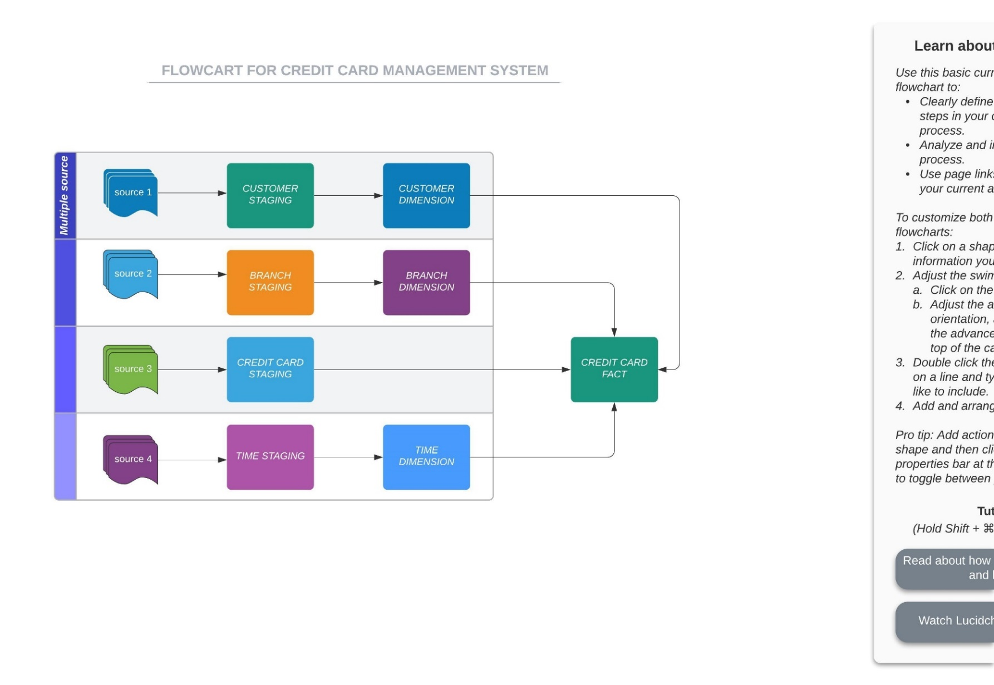

**1.4 Schema Diagram:**

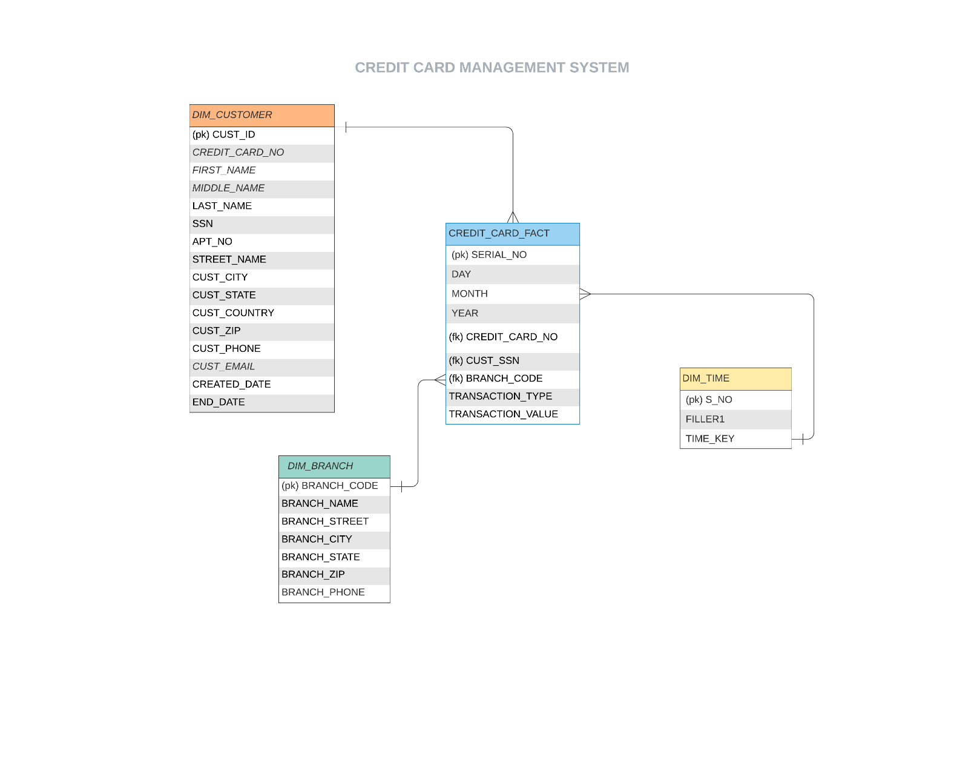

**2. Implementation**

* 1. **Customer Dimension**
* **Source File**

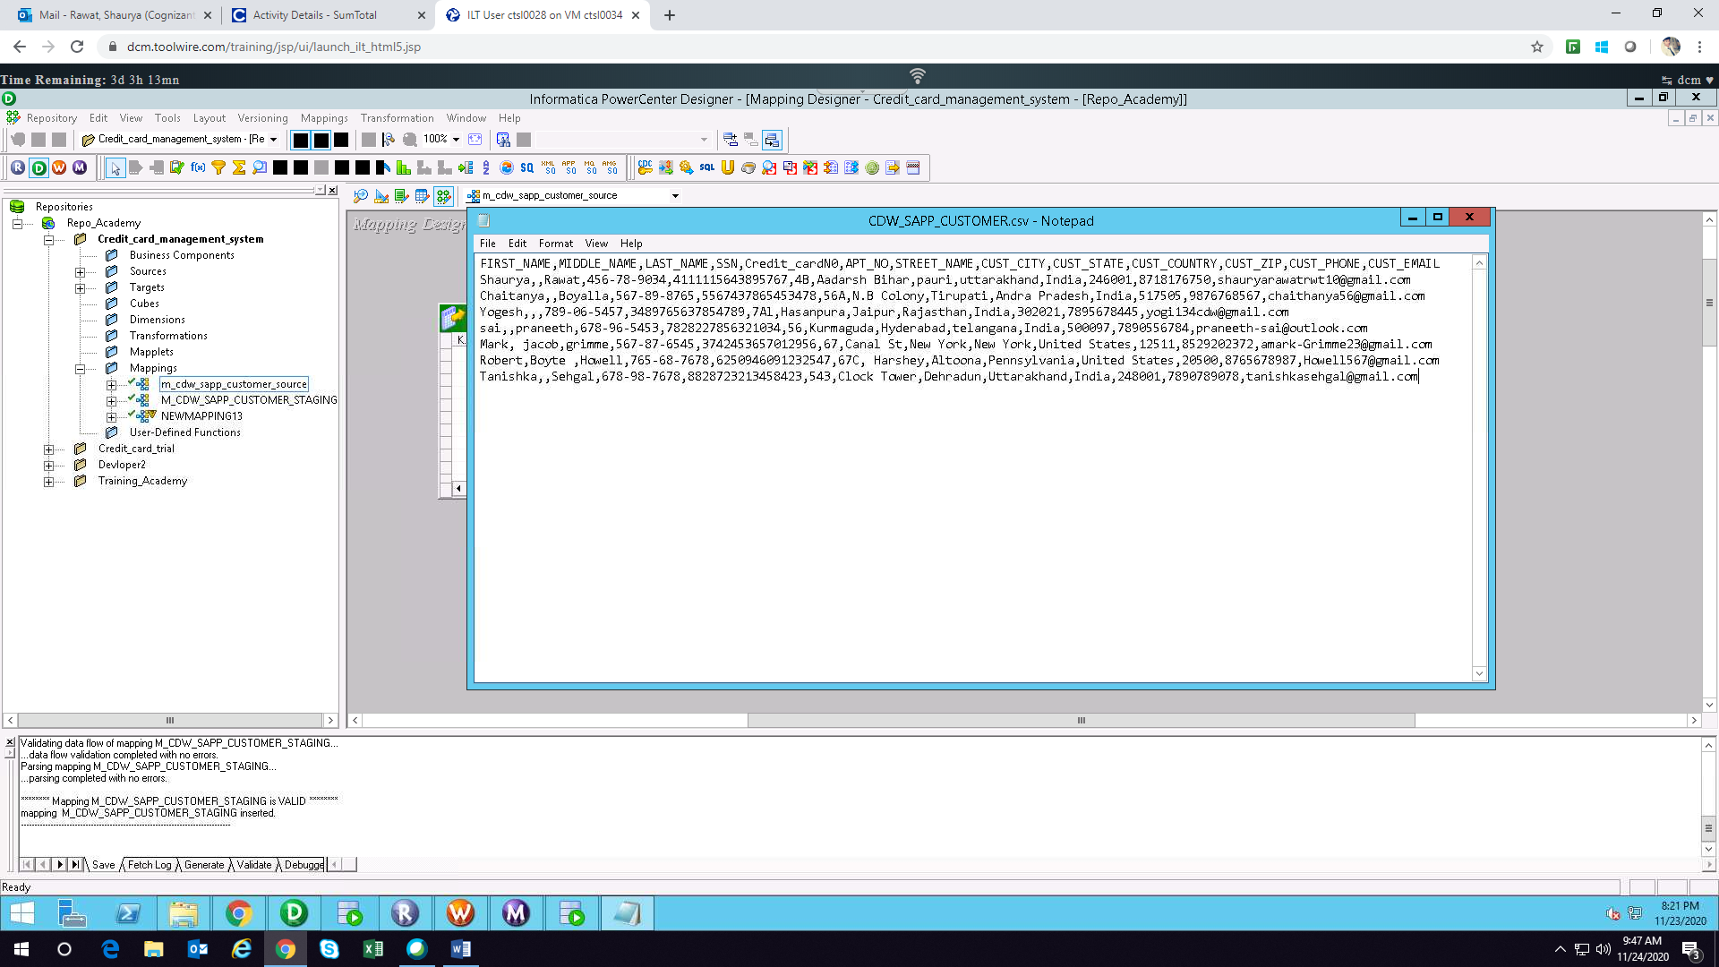



* **Staging Mapping**

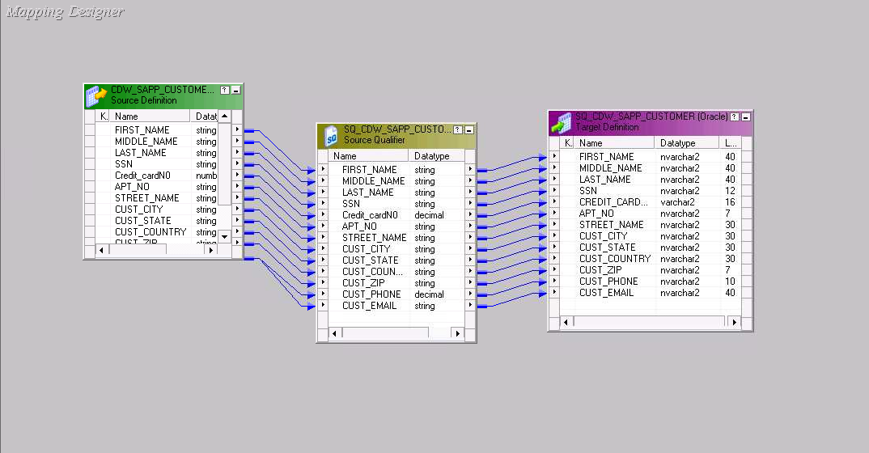

* **Staging Workflow and Session Properties**

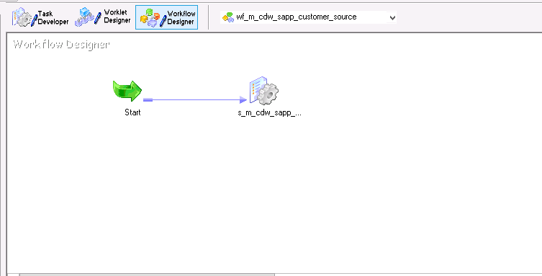

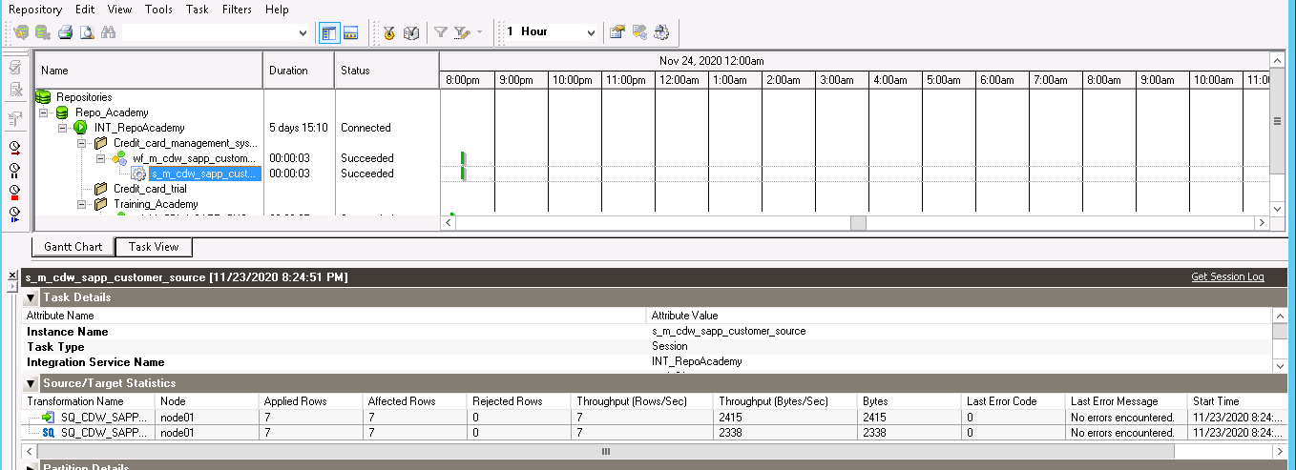

* **Database**

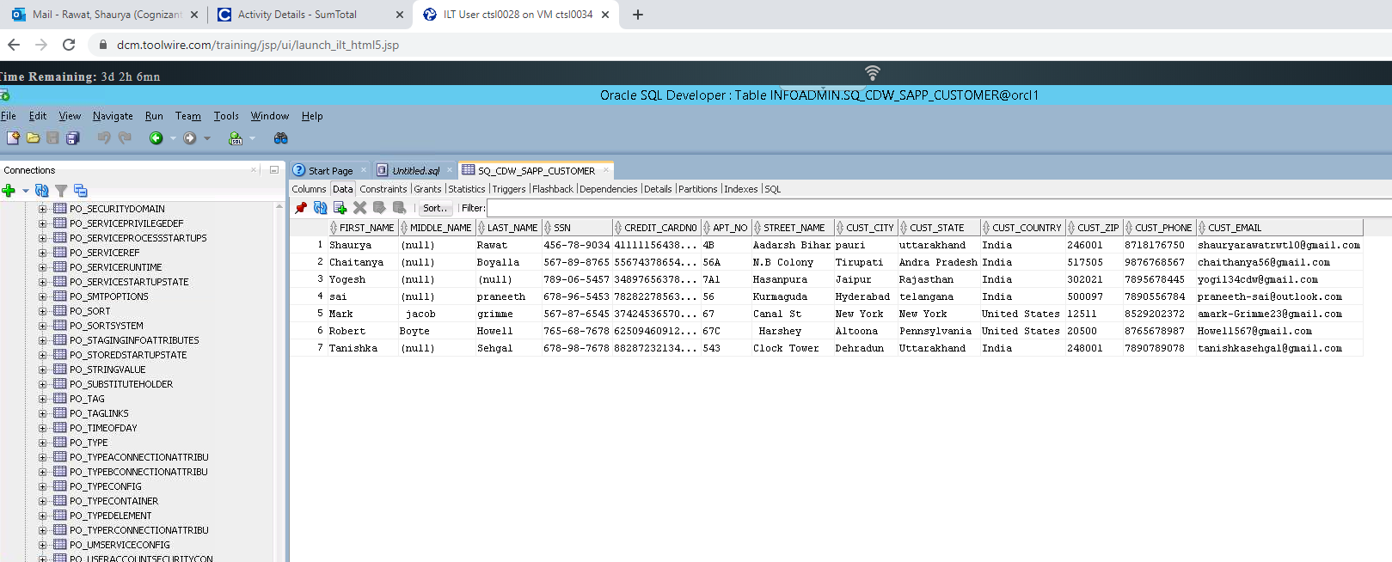

* **Dimension Mapping**

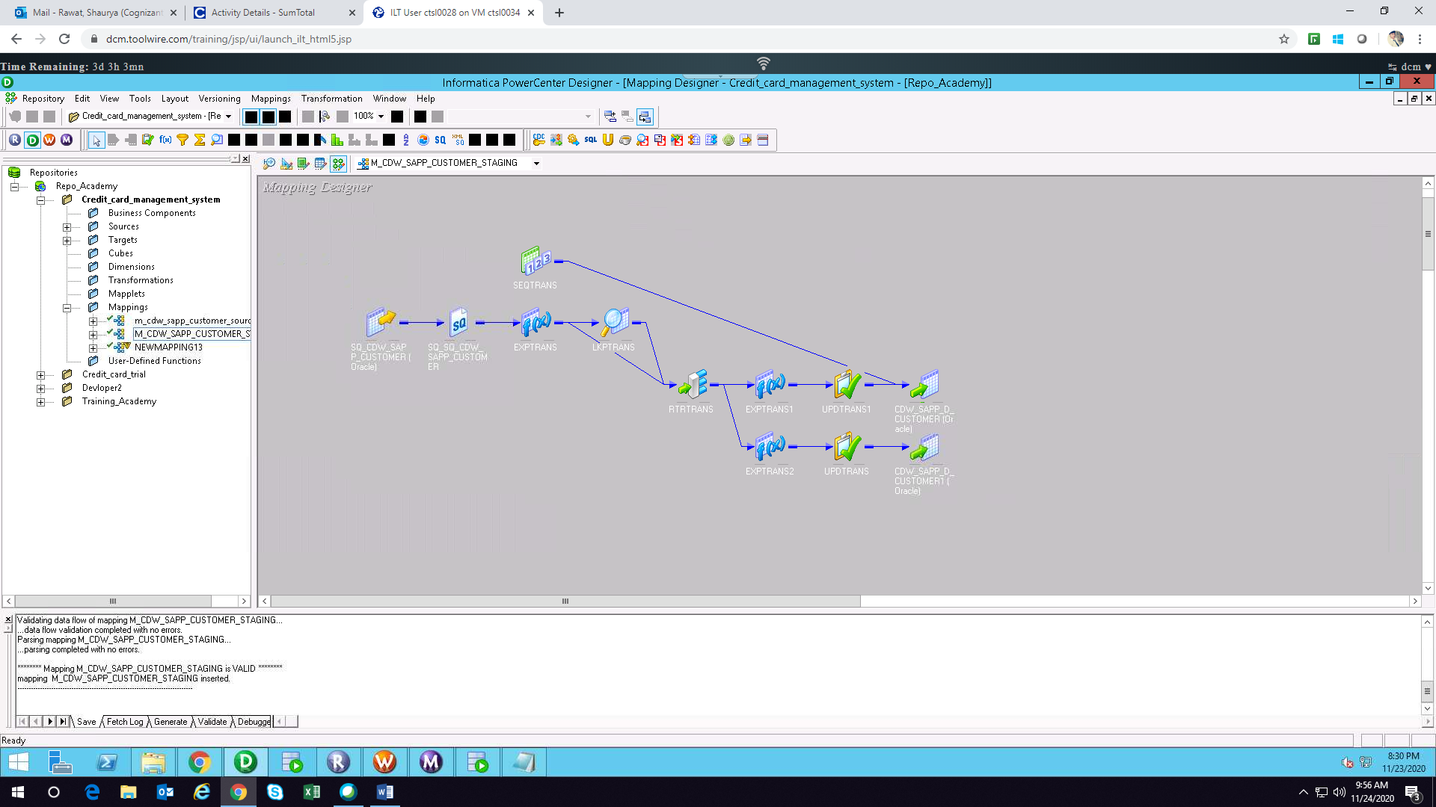

The Customer dimension mapping is of SCD type 2. We need following transformation for mapping source to dimension:

1. Source Qualifier Transformation
2. Expression Transformation (To Convert and validate records)
3. Lookup Transformation (To check existing records on target)
4. Router Transformation (To route records to update strategy for insert or update)
5. Expression Transformation (Add start date and end date based on update/insert)
6. Update Strategy Transformation (To DD_UPDATE or DD_INSERT)
7. Sequence Generator Transformation (Generate Primary key)

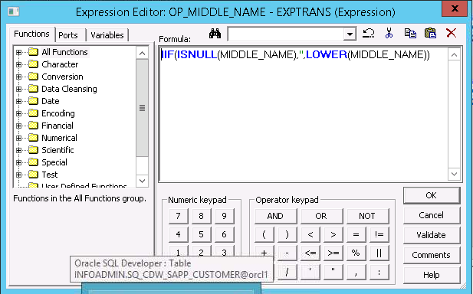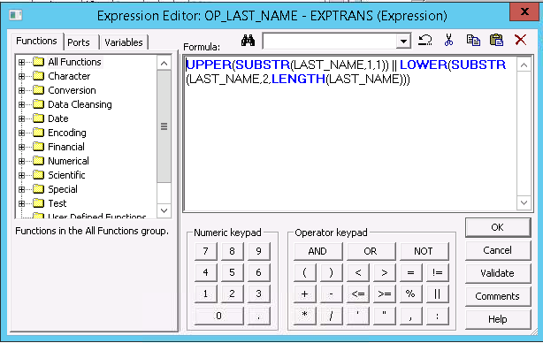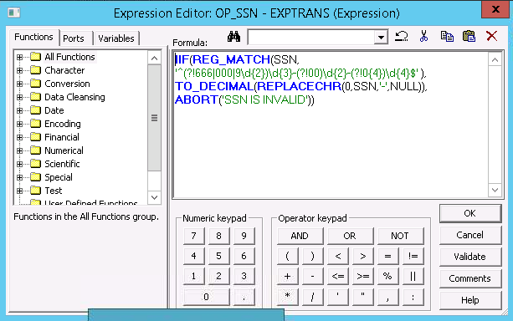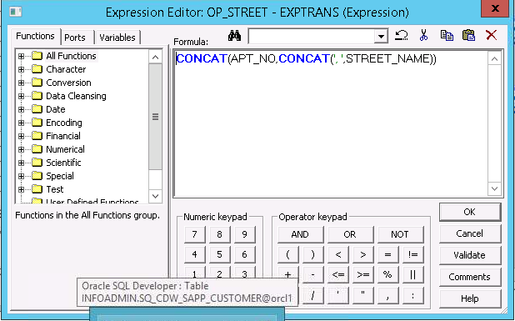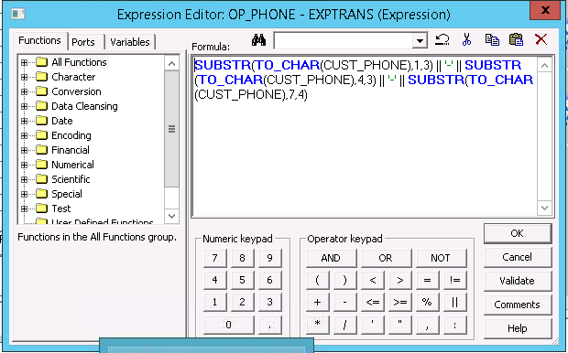

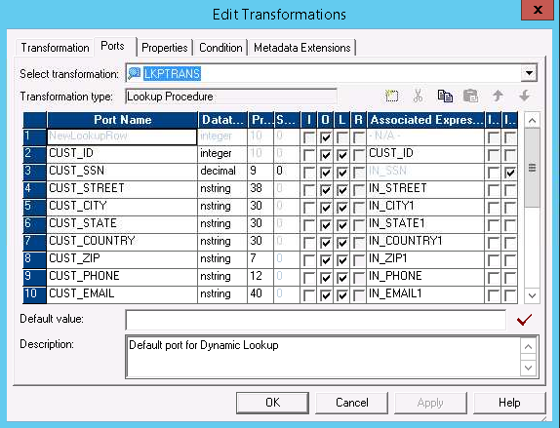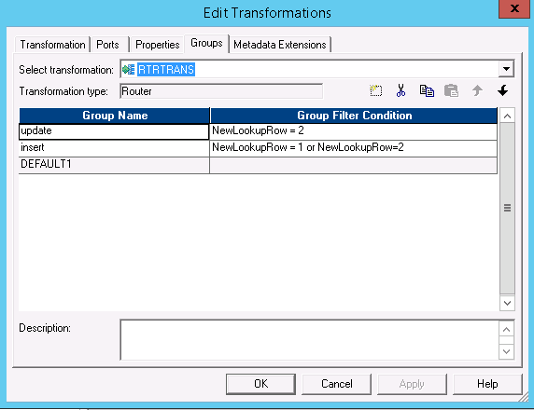

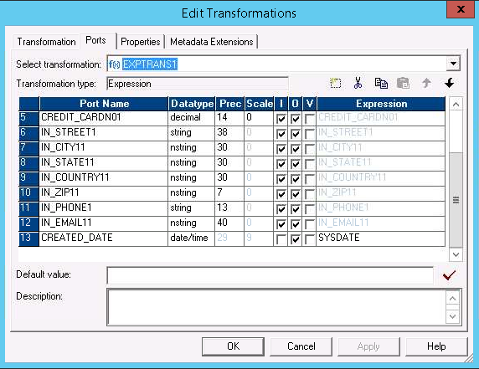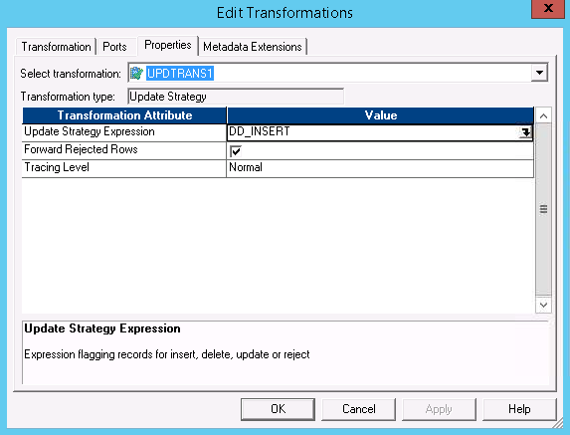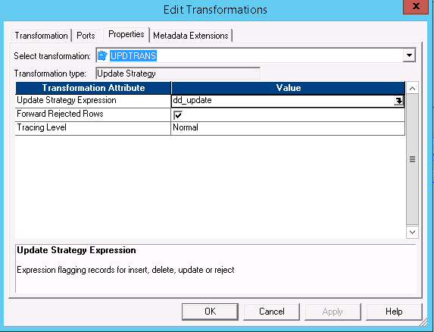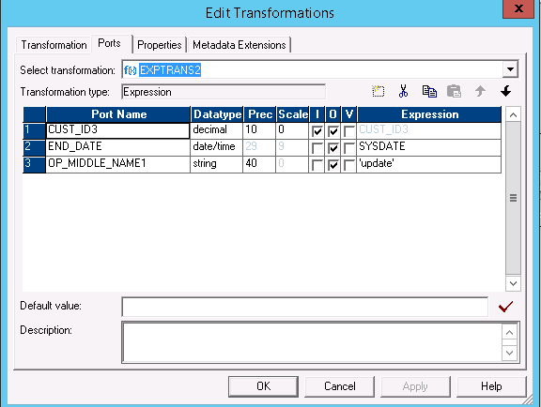

* **Dimension Workflow and Session Properties**

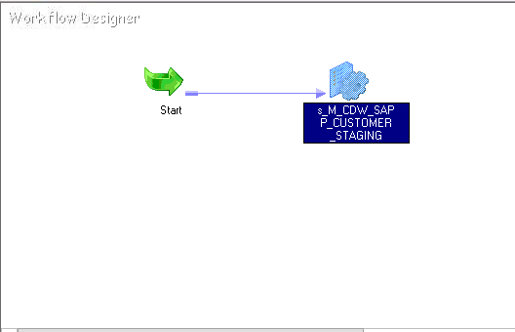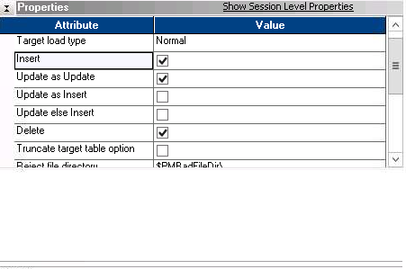

* **Database**

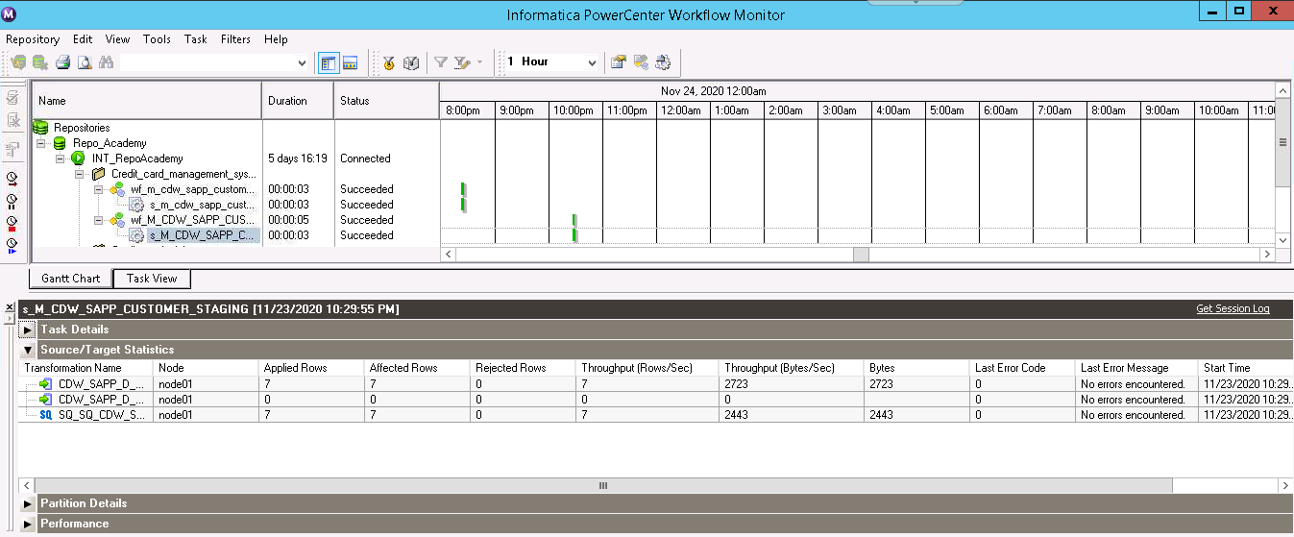

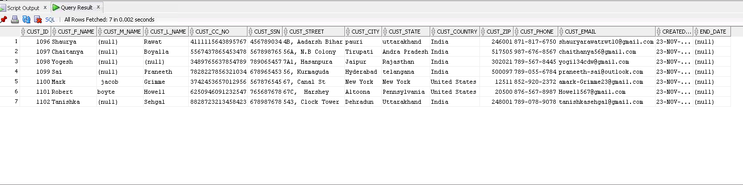

Now we can insert new or existing records in the dimension table (customer):

1. New records should be inserted with end date = null.
2. Existing record if match and don’t have any changes should be rejected.
3. Existing record if match and have some changes should be inserted and existing record end date should be generated and updated.
4. Invalid records should be rejected.

Update table SQ_CDW_SAPP_CUSTOMER set CUST_CITY = ‘mussorie’ where CUST_SSN = 456789034

Update table SQ_CDW_SAPP_CUSTOMER set APT_NO = 90 where CUST_SSN = 678965453

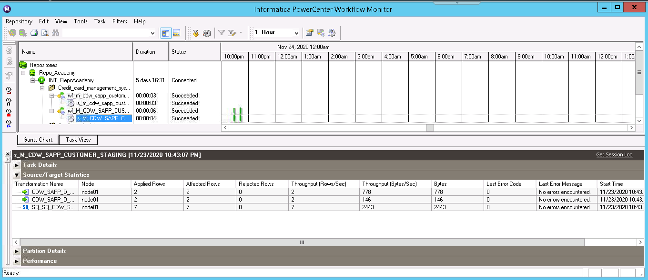

* **Database**

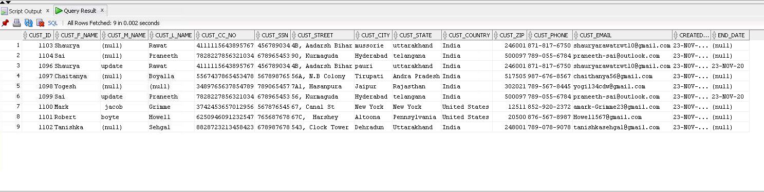

* 1. **Branch Dimension**

* **Source**

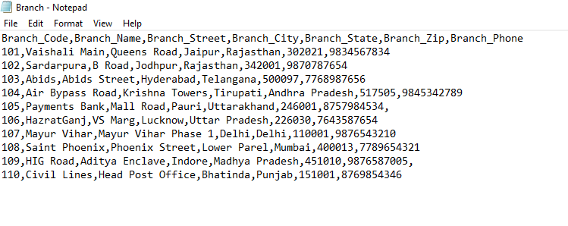



* **Staging Mapping**

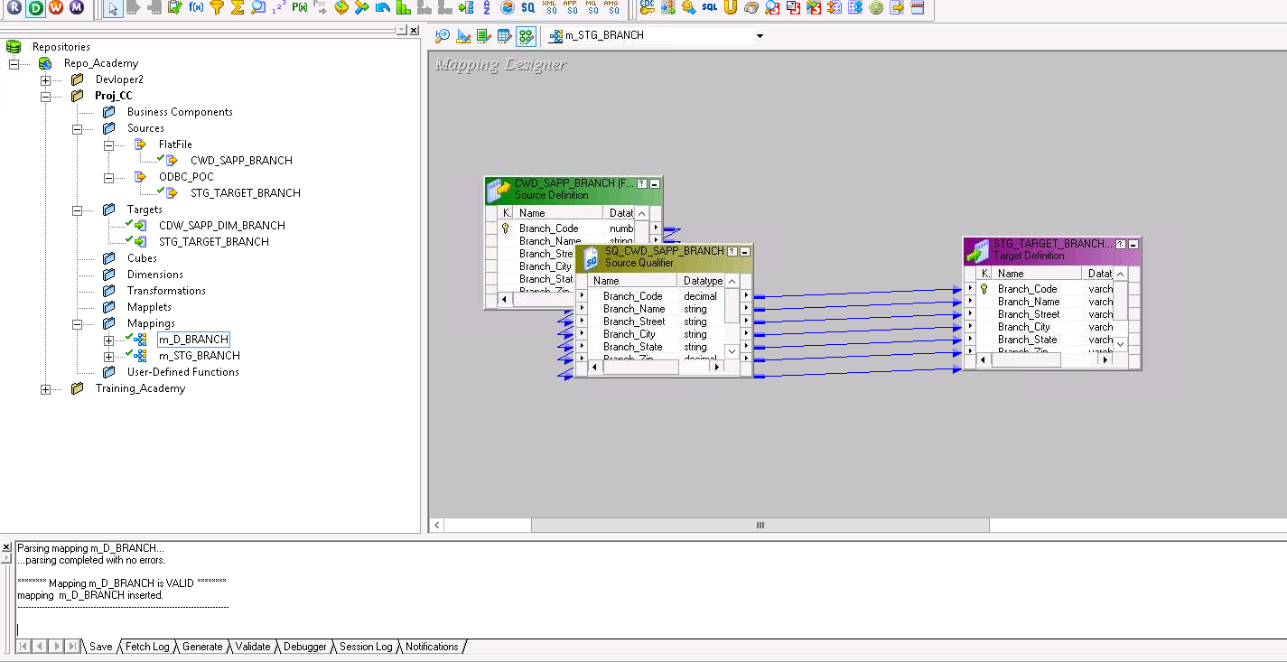

* **Staging Workflow and Session Properties**

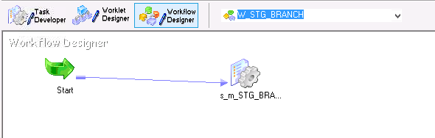

* **Database**

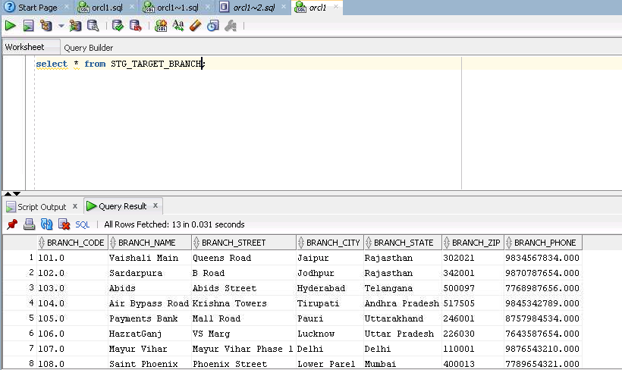

* **Dimension Mapping**

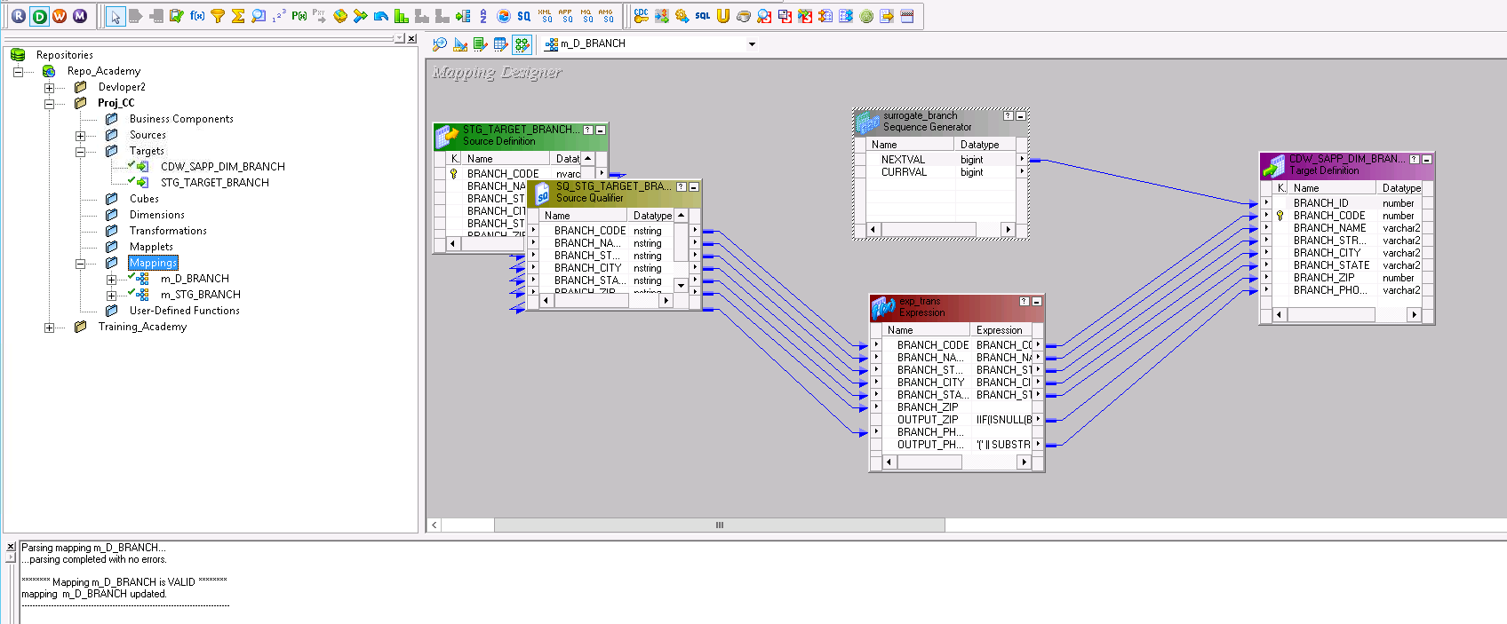

* **Transformations**

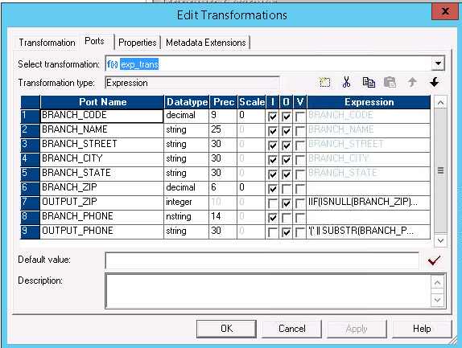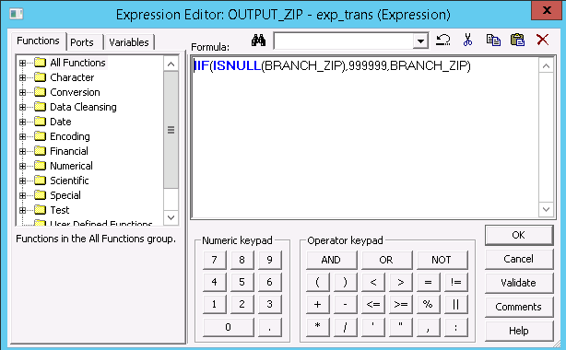

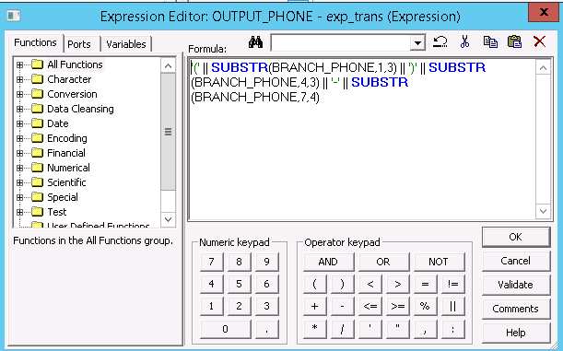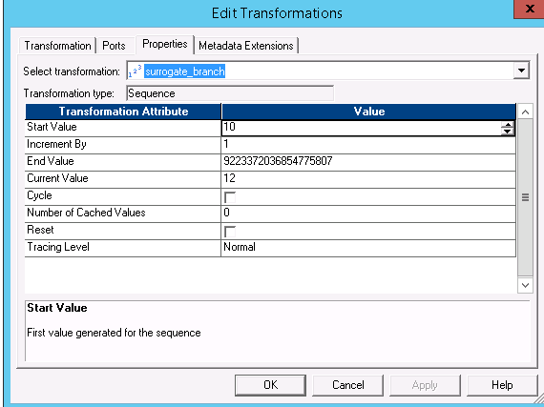

* **Dimension Workflow and Session Properties**

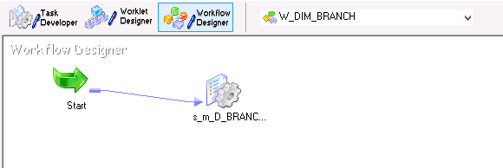

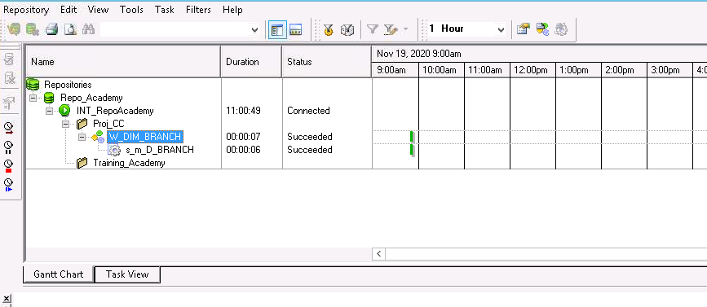

* **Database**

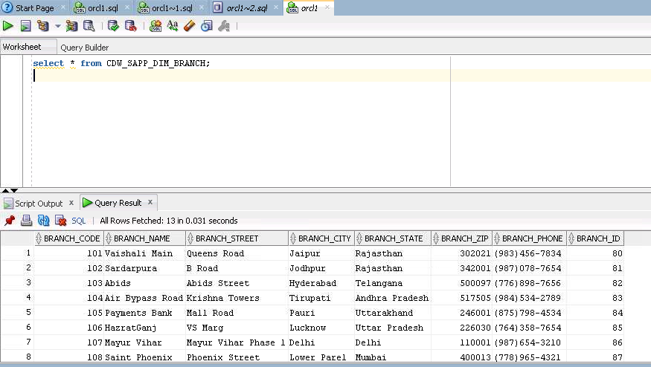

* 1. **Time Dimension**
  + **Source File**

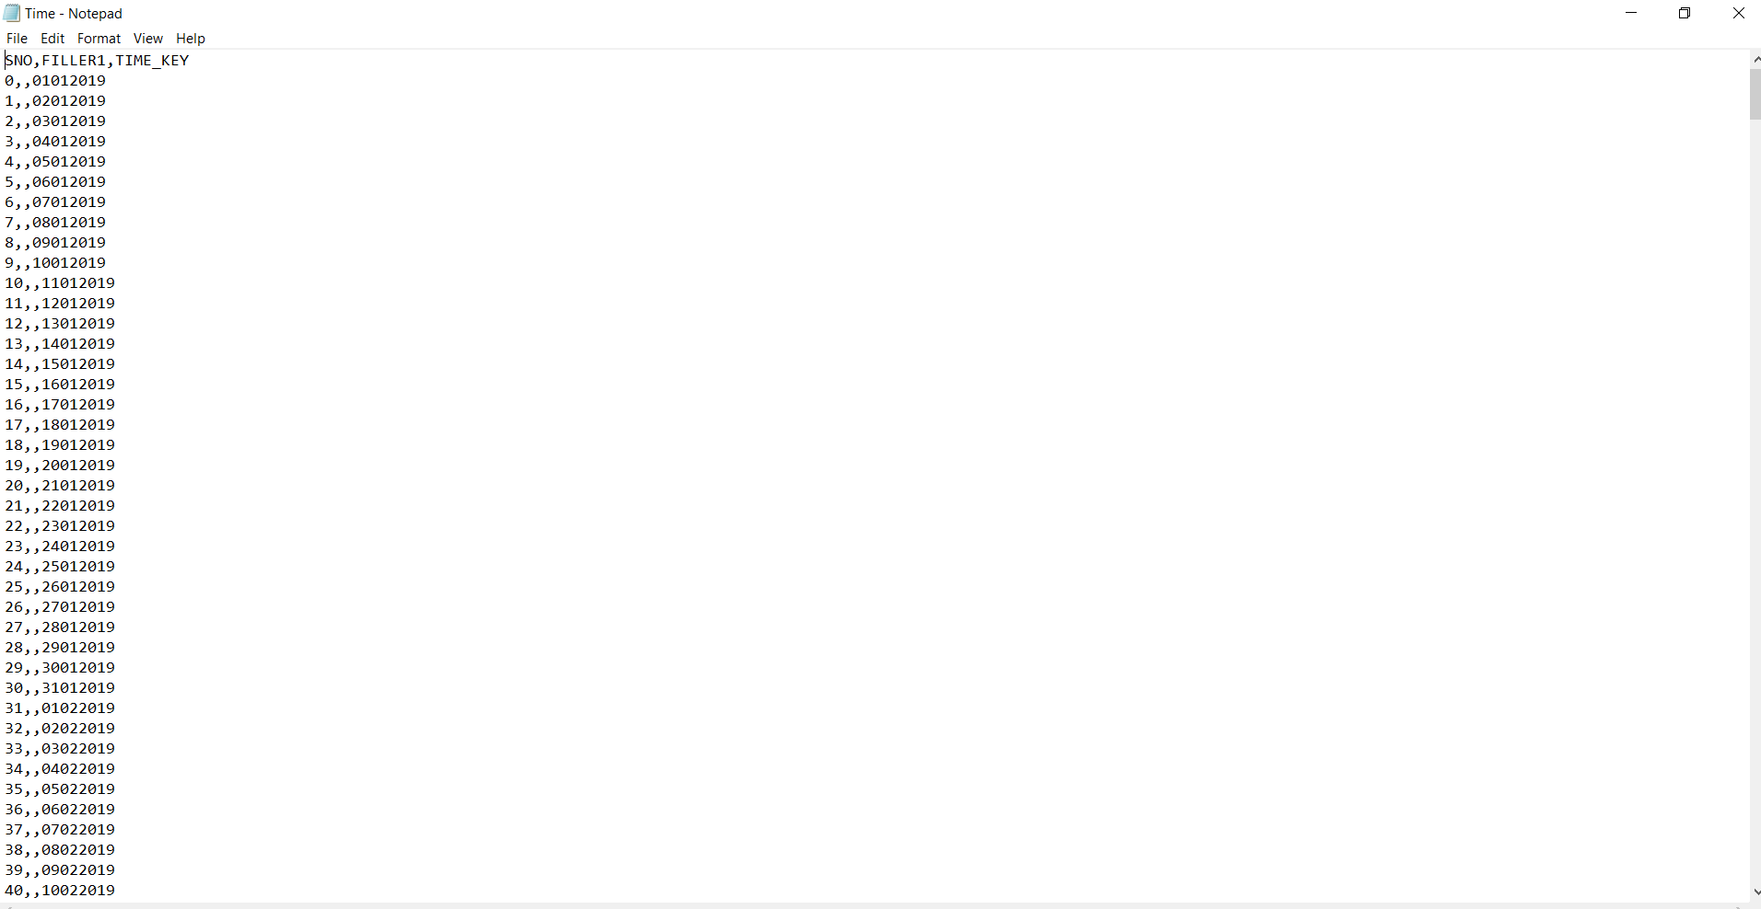

* + **Staging Mapping**

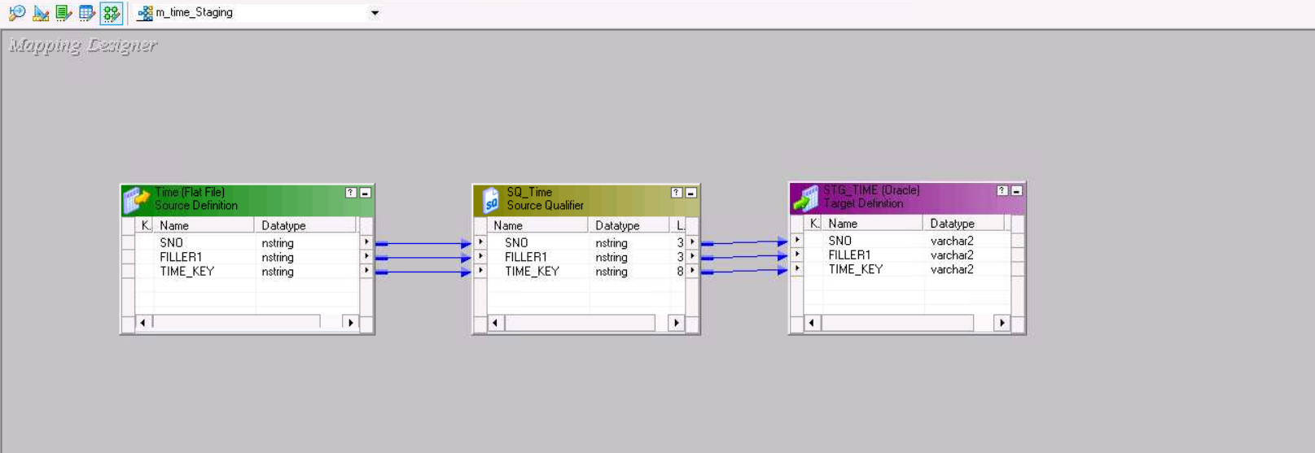

* + **Work Flow Monitor(Staging)**

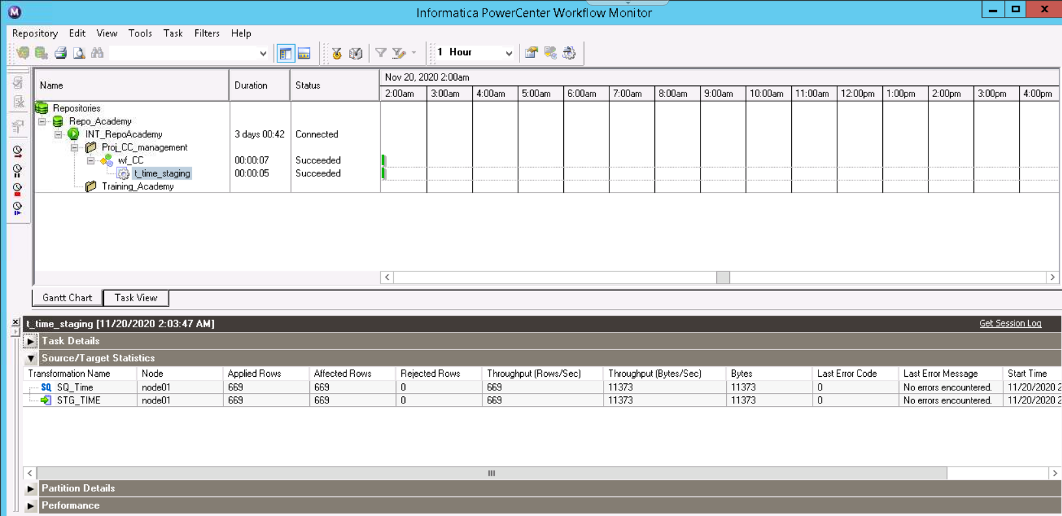

* + **Database table (Staging)**

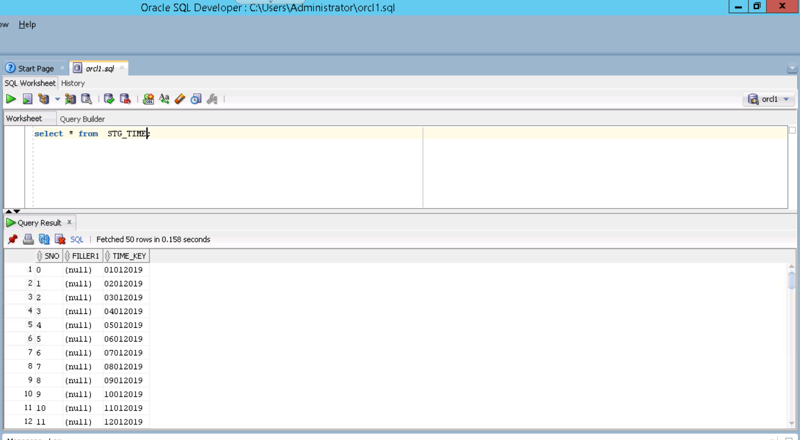

* + **Dimension Mapping**

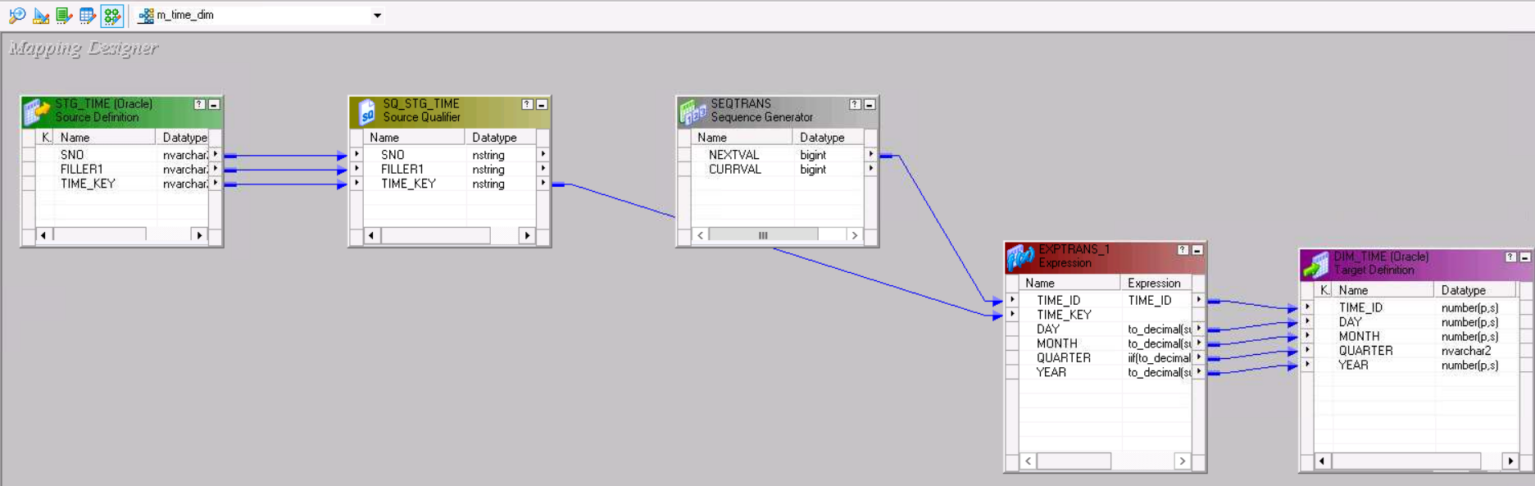

* + **Transformations (Dimension)**

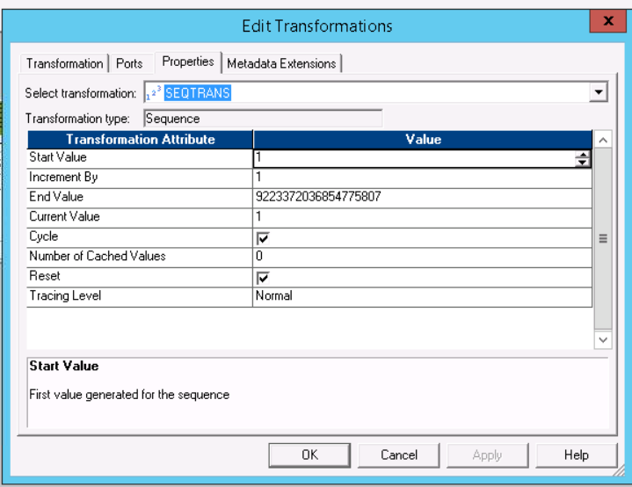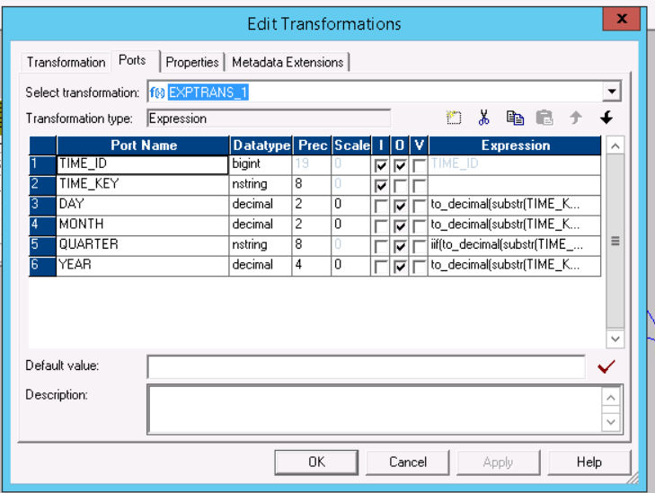

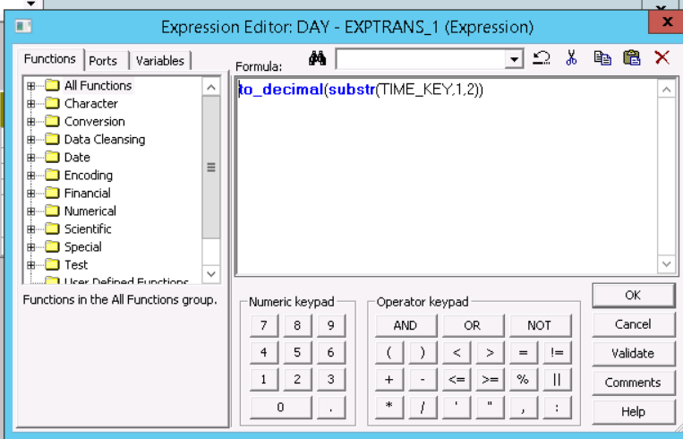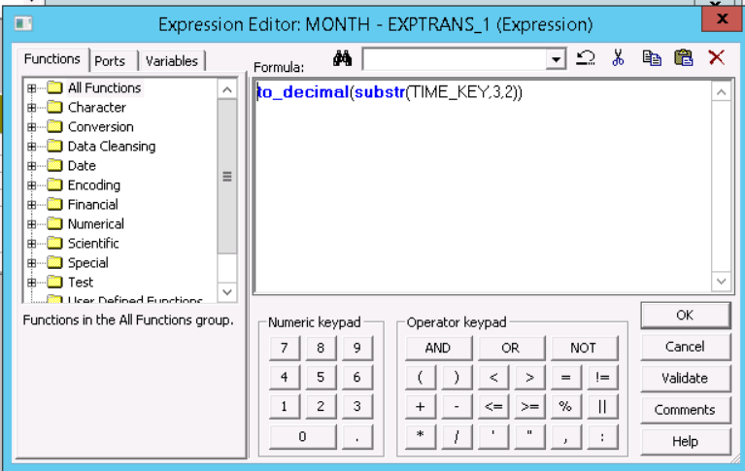

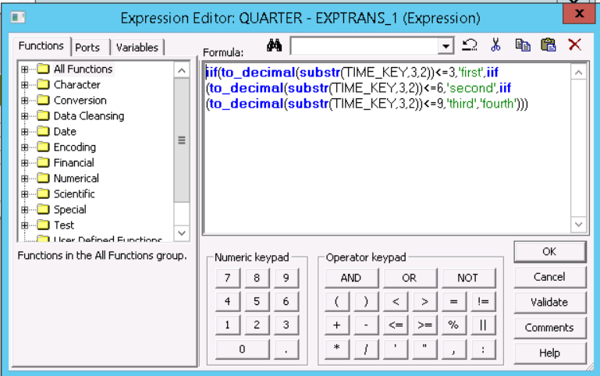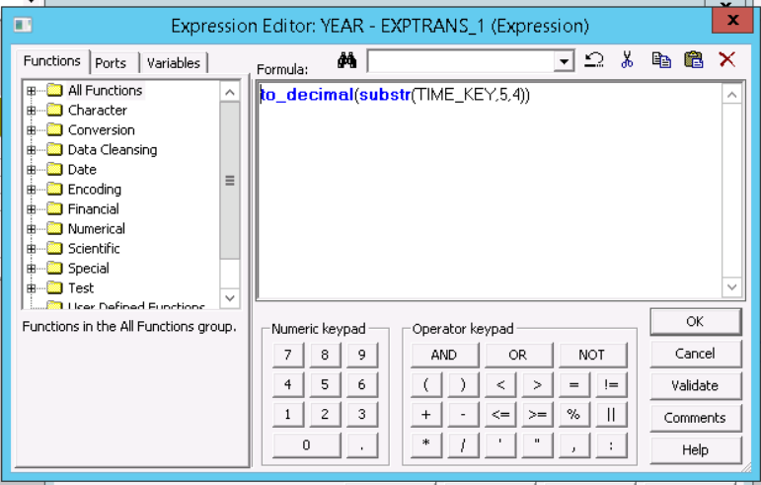

* + **Work Flow Monitor (Dimension)**

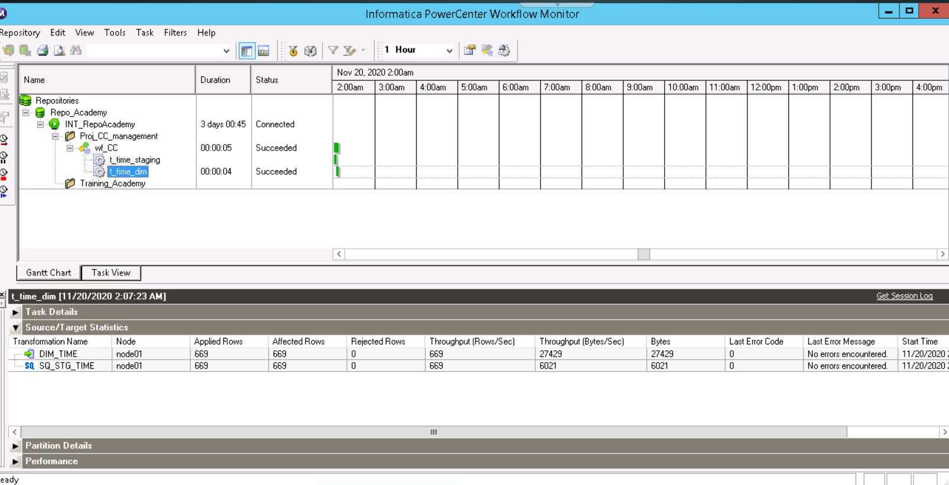

* + **Database (Dimension)**

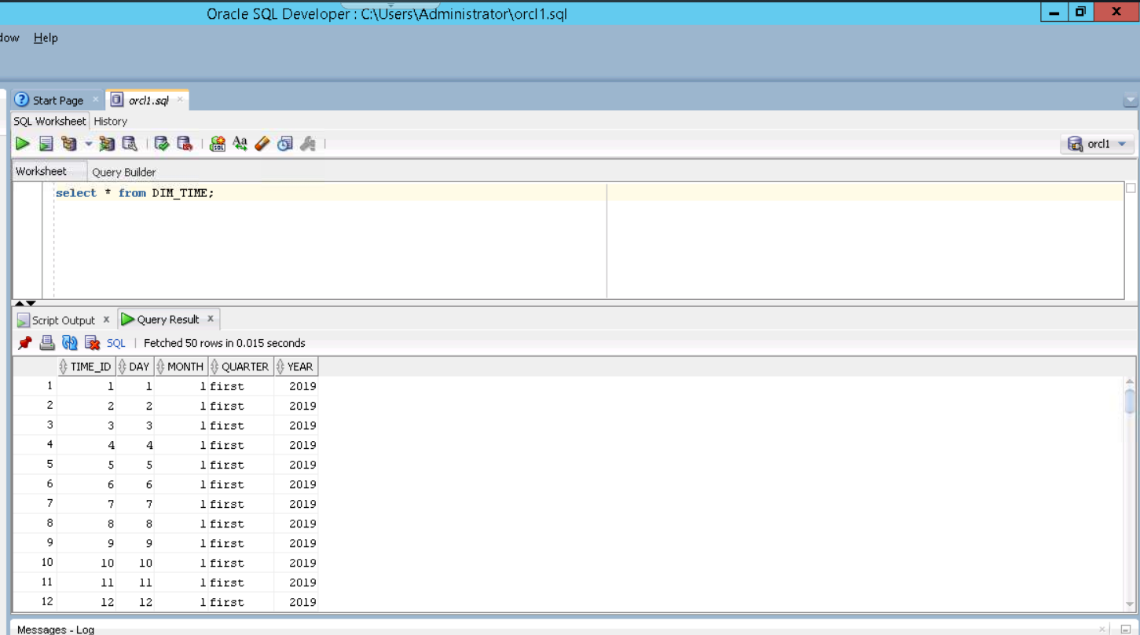

* 1. **Credit Card Dimension (Fact Table)**
* **Source File**

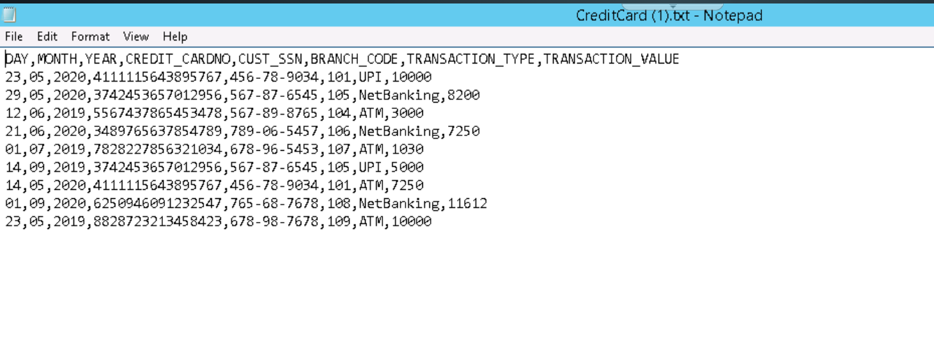

* **Staging Mapping**

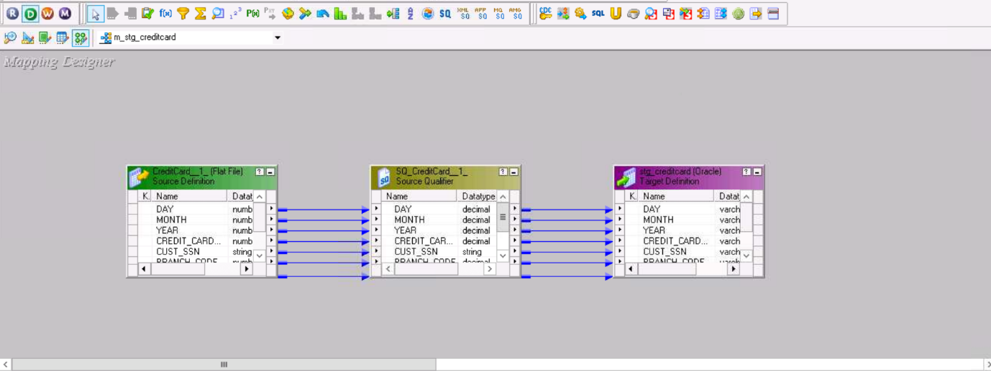

* **Staging Workflow and Session Properties**

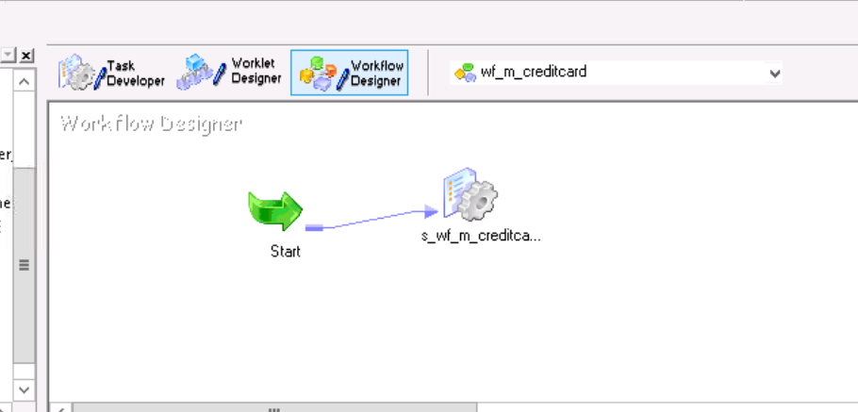

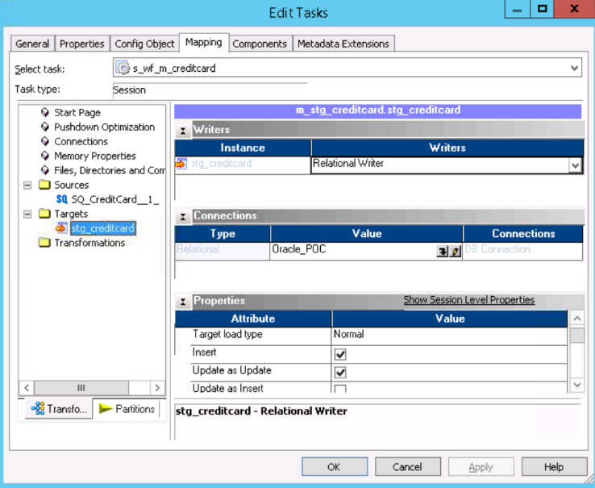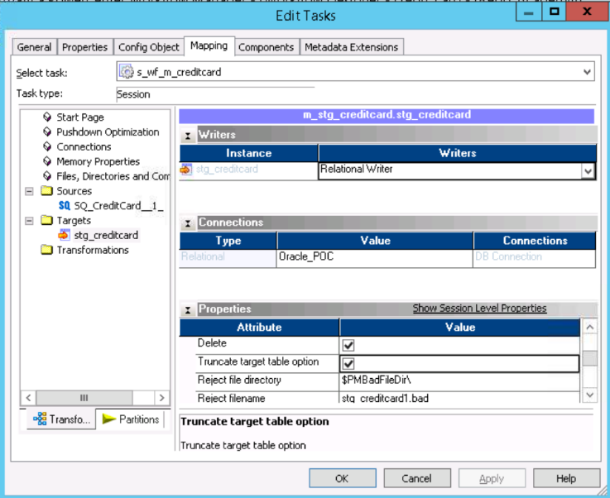

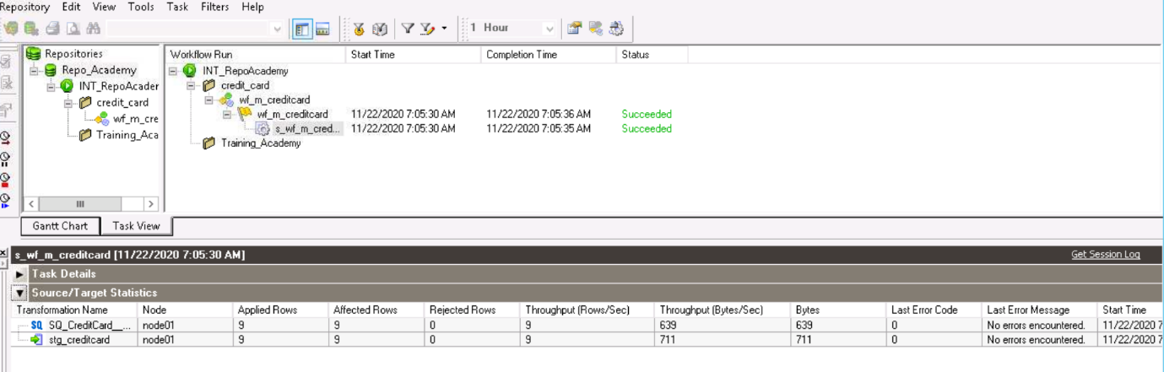

* **Database**

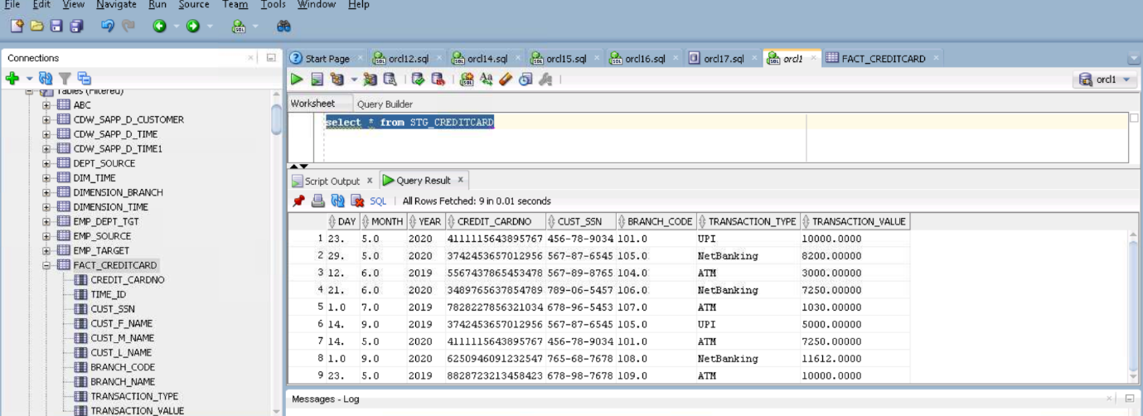

* **Fact Mapping**

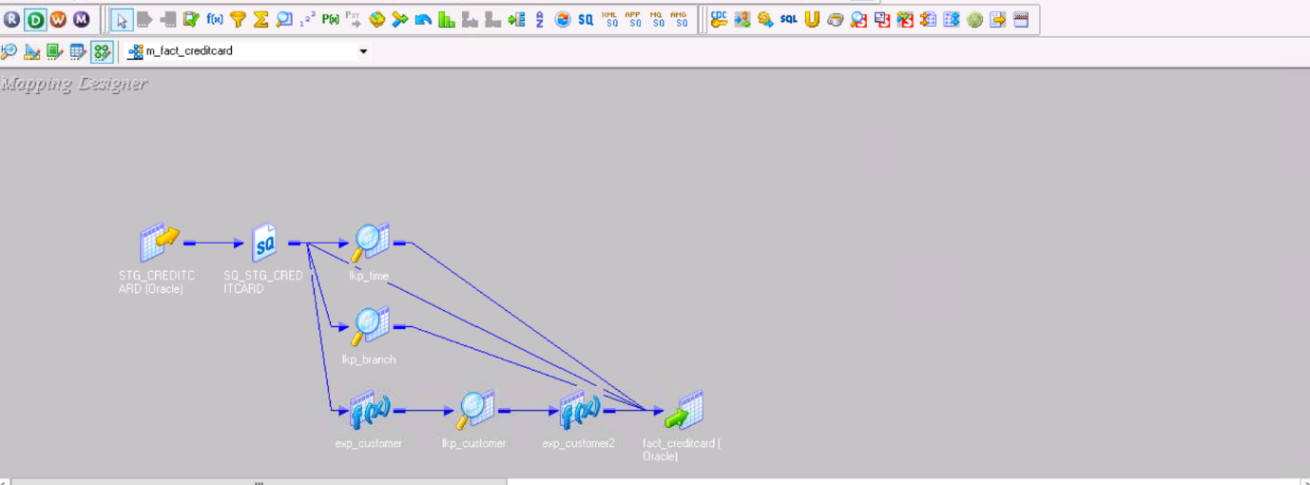

* **Transformations**

Look up conditions on time dimension

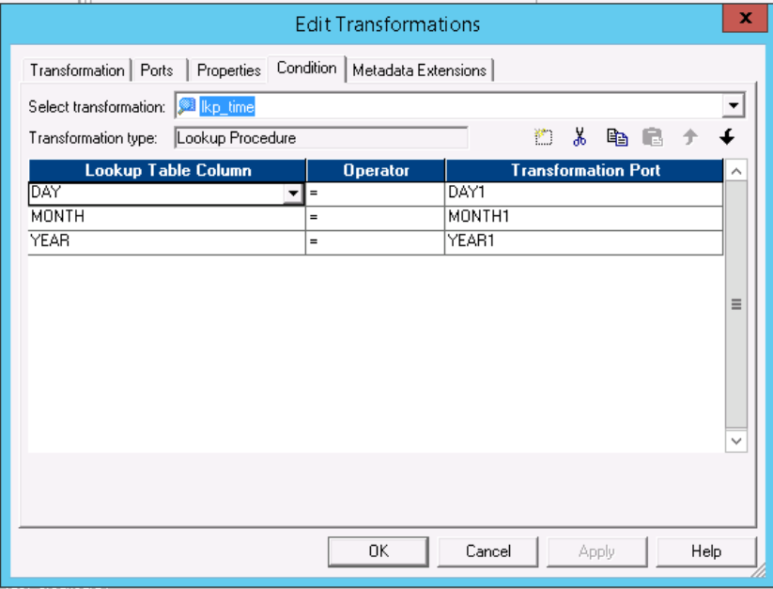

Look up conditions on branch dimension:

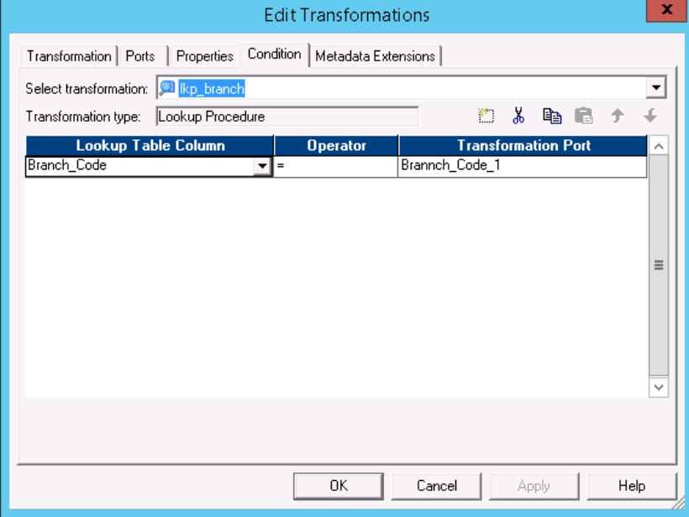

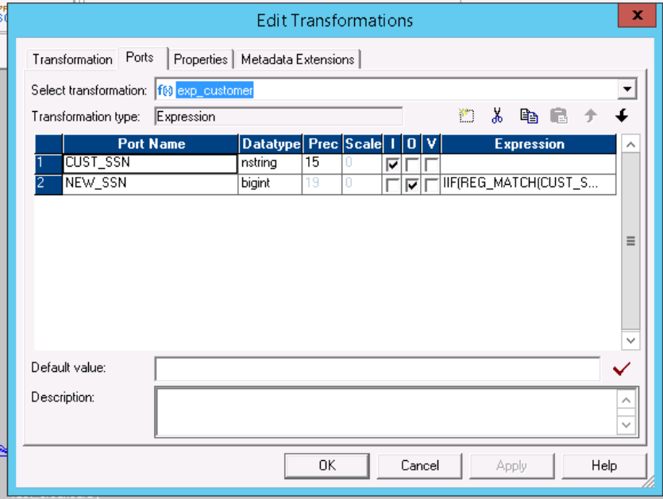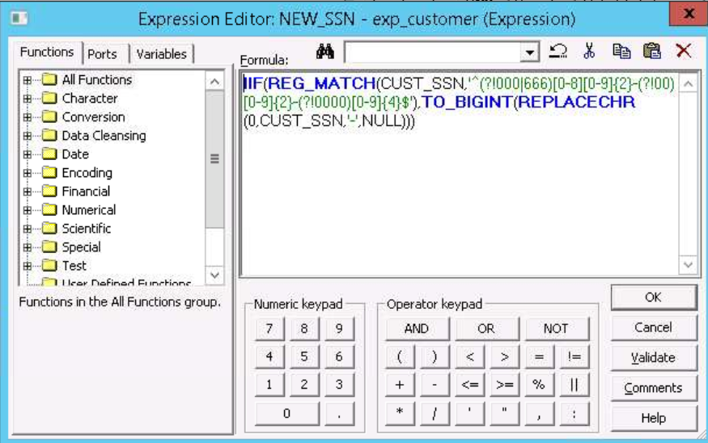

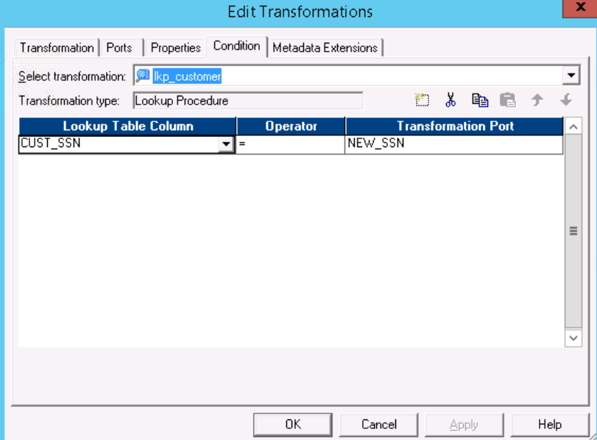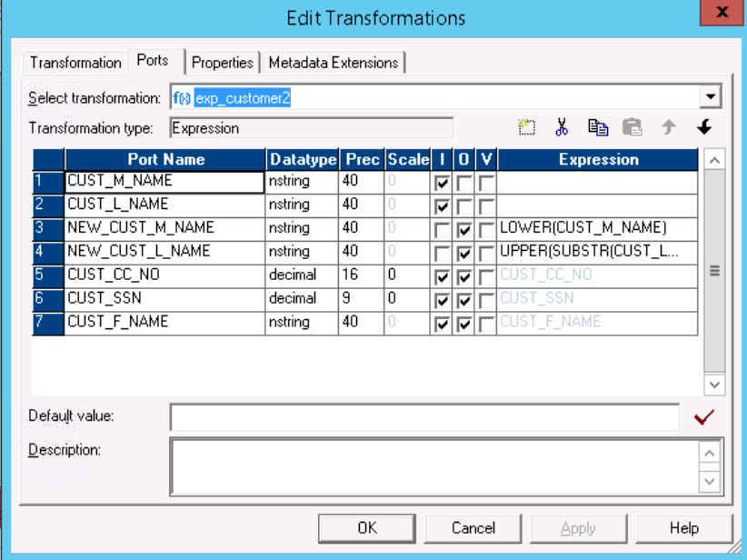

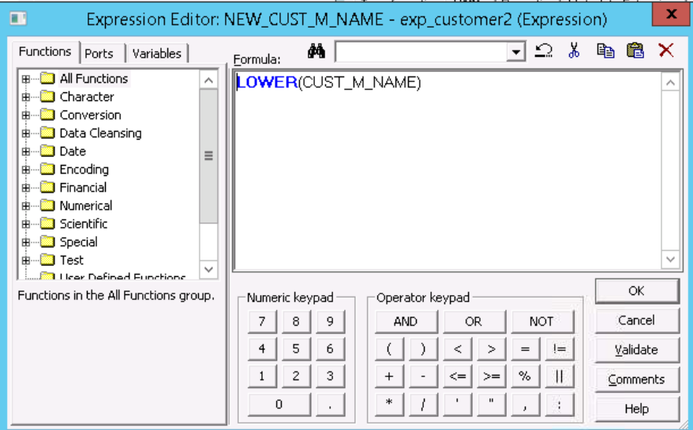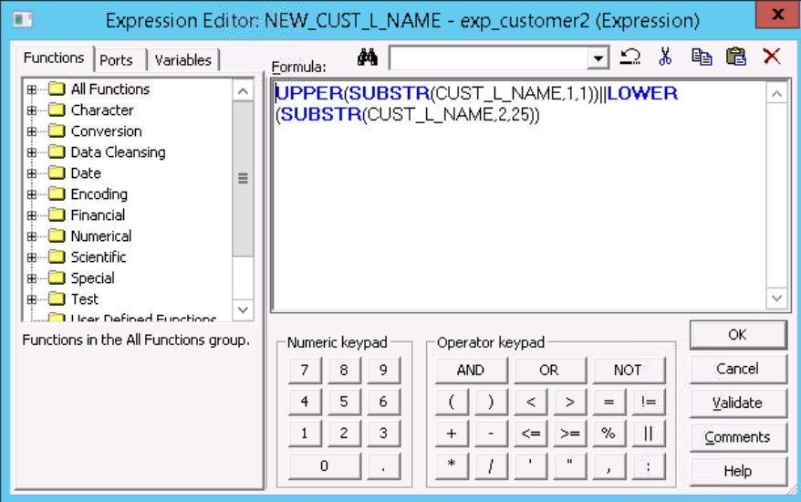

* **Fact Workflow and Session Properties**

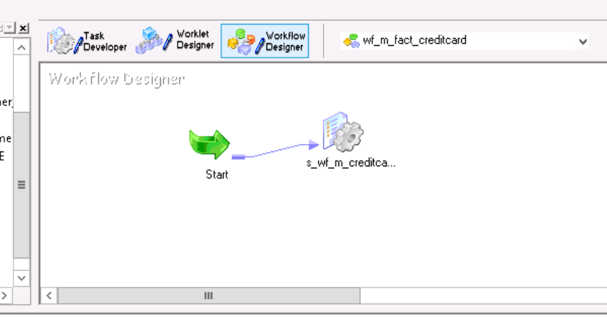

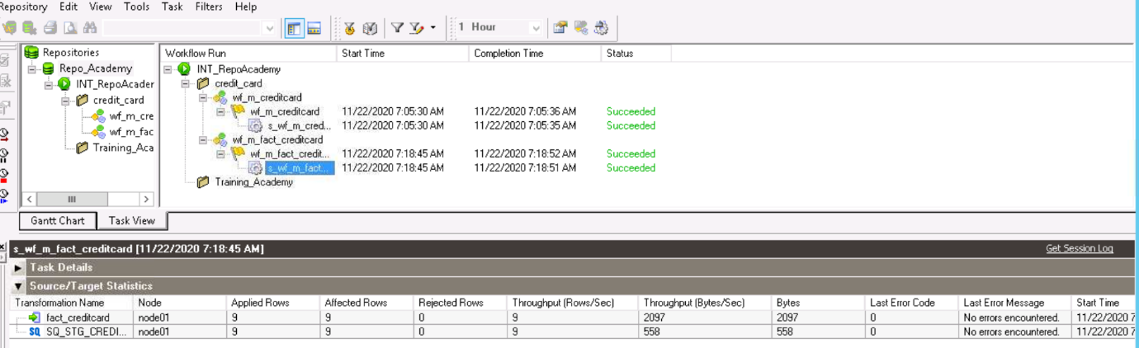

* **Database**

